|  |
| --- |
| Hewlett-Packard |
| Software Testing A3 |
| White Box Testing |
| Group Members  Bilal Sabeel (BSE173115)  Hamza Shakeel (BSE173163)  Raja Nasir (BSE173140)  Muhammad Hassan (BSE173155) |
|  |

# Black Box Testing

1. **Attempt cause effect graphing and**

* Identify all causes and effects
* Draw cause effect graph
* Draw decision table
* Identify test cases
* Write down test cases

University has admission criteria. AL teat 50% marks in Matric, FSC marks and in admission test are required in order to get admission in university. University prepare merit list by calculating student aggregate. Student must be 50% marks in on order to pass the subject. There is midterm of weightage 20%, final term of weightage 40%, and other 40% number contain quizzes, assignments, project depend upon courses and teachers. Normally quizzes contain 20% and assignment contain 20% of marks. University have attendance criteria. Maximum 8 leave allow per subject. There is no fine in first your leave and 200 hundred rupee fine per leave.

**Function**

**F1**

int calculateAggreagate( matricMarks, fscMarks, admissionTestMarks)

MatricMarks range 50%-100% 20% consider

fscMarks range 50%-100% 30% consider

admissionTestMarks range range 50%-100% 50% consider

**F2**

int calculateFinalResult(mid, final, others)

mid range 0-20

final range 0-40

others range 0-40

**F3**

int fineCalculate(leave)

leave range 0-8

**Identify all causes and effects**

**F1**

int calculateAggreagate( matricMarks, fscMarks, admissionTestMarks)

|  |  |
| --- | --- |
| **Causes** | **Effects** |
| **C1->** Matric Marks >=50% && <=100% | **E1->** calculated final result of students |
| **C2->** fscMarks >=50% && <=100% | **E2->** invalid range |
| **C3->** admissionTestMarks >=50% && <=100% |  |
|  |  |

**Draw cause effect graph**

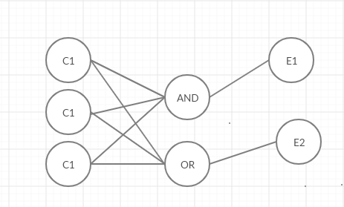

**Decision Table**

|  |  |  |  |  |  |  |  |  |
| --- | --- | --- | --- | --- | --- | --- | --- | --- |
| **Action** | **T1** | **T2** | **T3** | **T4** | **T5** | **T6** | **T7** | **T8** |
| **C1** | 0 | 0 | 0 | 0 | 1 | 1 | 1 | 1 |
| **C2** | 0 | 0 | 1 | 1 | 0 | 0 | 1 | 1 |
| **C3** | 0 | 1 | 0 | 1 | 0 | 1 | 0 | 1 |
| **E1** | 0 | 0 | 0 | 0 | 0 | 0 | 0 | 1 |
| **E2** | 1 | 1 | 1 | 1 | 1 | 1 | 1 | 0 |

**Test Cases**

|  |  |  |  |  |
| --- | --- | --- | --- | --- |
| **Test case** | **Input** | | | **(Effects)** |
| **Matric Marks** | **fscMarks** | **admissionTestMarks** |
| **T1** | 35 | 45 | 34 | (-1)Invalid Range |
| **T2** | 45 | 32 | 67 | (-1)Invalid Range |
| **T3** | 40 | 65 | 34 | (-1)Invalid Range |
| **T4** | 45 | 80 | 78 | (-1)Invalid Range |
| **T5** | 60 | 44 | 43 | (-1)Invalid Range |
| **T6** | 60 | 44 | 70 | (-1)Invalid Range |
| **T7** | 60 | 70 | 43 | (-1)Invalid Range |
| **T8** | 62 | 75 | 70 | 69 |

**F2**

int calculateFinalResult(mid, final, others)

|  |  |
| --- | --- |
| **Causes** | **Effects** |
| **C1->** mid >=0% && <=20% | **E1->** calculated aggregate of students |
| **C2->** final >=0% && <=40% | **E2->** invalid range |
| **C3->** others >=0% && <=40% |  |
|  |  |

**Draw cause effect graph**

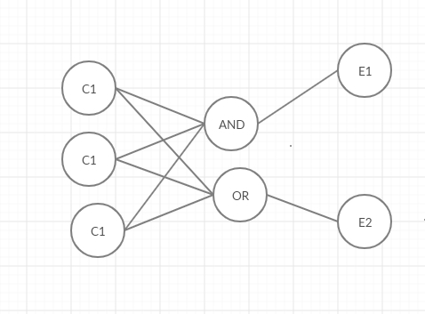

**Decision Table**

|  |  |  |  |  |  |  |  |  |
| --- | --- | --- | --- | --- | --- | --- | --- | --- |
| **Action** | **T1** | **T2** | **T3** | **T4** | **T5** | **T6** | **T7** | **T8** |
| **C1** | 0 | 0 | 0 | 0 | 1 | 1 | 1 | 1 |
| **C2** | 0 | 0 | 1 | 1 | 0 | 0 | 1 | 1 |
| **C3** | 0 | 1 | 0 | 1 | 0 | 1 | 0 | 1 |
| **E1** | 0 | 0 | 0 | 0 | 0 | 0 | 0 | 1 |
| **E2** | 1 | 1 | 1 | 1 | 1 | 1 | 1 | 0 |

**Test Cases**

|  |  |  |  |  |
| --- | --- | --- | --- | --- |
| **Test case** | **Input** | | | **(Effects)** |
| **Mid** | **Final** | **Others** |
| **T1** | 25 | 45 | 90 | (-1) Invalid Range |
| **T2** | 30 | 41 | 36 | (-1)Invalid Range |
| **T3** | 40 | 35 | 89 | (-1)Invalid Range |
| **T4** | 45 | 30 | 30 | (-1)Invalid Range |
| **T5** | 20 | 44 | 43 | (-1)Invalid Range |
| **T6** | 15 | 44 | 30 | (-1)Invalid Range |
| **T7** | 11 | 40 | 60 | (-1)Invalid Range |
| **T8** | 5 | 40 | 40 | 85 |

**F3**

int fineCalculate(leave)

|  |  |
| --- | --- |
| **Causes** | **Effects** |
| **C1->** leave >=0 && <= 8 | **E1->** calculated fine of students |
|  | **E2->** invalid range |
|  |  |

**Graph**

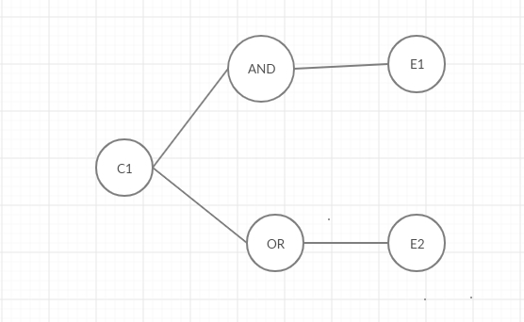

**Decision Table**

|  |  |  |
| --- | --- | --- |
| **Action** | **T1** | **T2** |
| **C1** | 0 | 1 |
| **E1** | 1 | 0 |
| **E2** | 1 | 0 |

**Test Cases**

|  |  |  |
| --- | --- | --- |
| **Test case** | **Input** | **Output** |
|  | **leave** |  |
| **T1** | **10** | (-1)**Invalid** |
| **T2** | **6** | **400** |